Software Engineering Lab 2 Submission
Name: Adithya Ajeeth
SRN: PES1UG24CS022

EPICs
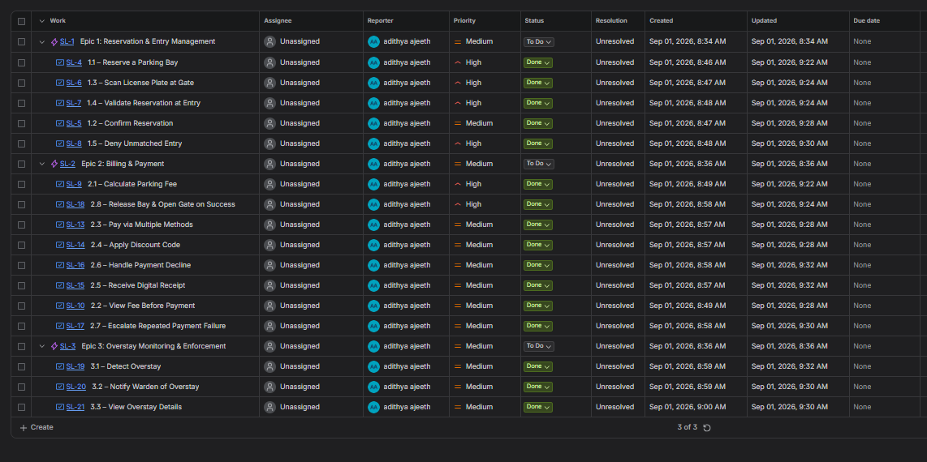

Burndown charts
Sprint 1
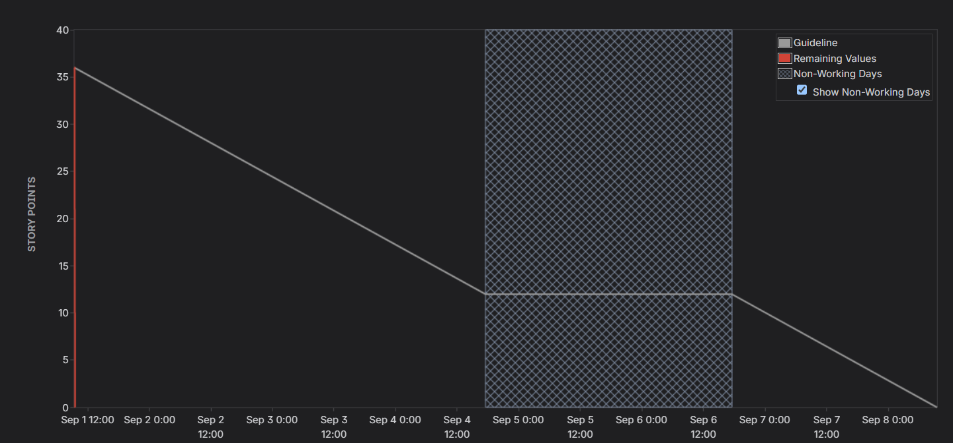
Sprint 2
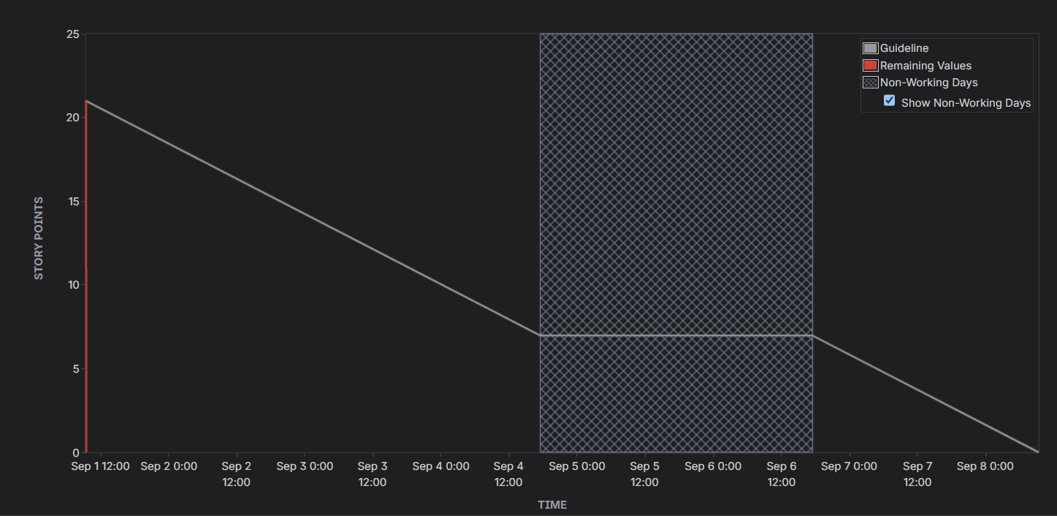

Reflection Questions
Q1. Did your estimations reflect the actual effort?
Not entirely. Since this was a simulated sprint rather than real development work, story points were assigned based on anticipated complexity rather than effort actually observed while building. In a real team setting, this is exactly why sprints are run iteratively: after Sprint 1, you'd compare planned points to actual time/effort spent and recalibrate. For example, a task like "Validate Reservation at Entry" might look moderate on paper but could end up involving more edge-case handling in practice than initially estimated. The exercise highlighted that estimation is really a discussion tool for building team consensus, not a precise forecast.
Q2. Was your backlog well-prioritized?
Yes, largely. High-priority items were the ones foundational to the core user journey like reserving a bay, validating entry, calculating fees, and releasing the bay/gate on payment, since none of the later features (discounts, multiple payment methods, overstay alerts) matter if a vehicle can't even get validated at the gate or billed correctly. Medium-priority items (discount codes, overstay notifications, receipts) enhance the experience but aren't blocking. This dependency-aware ordering meant Sprint 1 could focus on a working end-to-end flow before layering on convenience and enforcement features in Sprint 2.
Q3. How did your simulated sprint align with your plan?
The sprint execution matched the plan reasonably well — items selected for Sprint 1 were moved through To Do → In Progress → Done and completed within the simulated window. However, because this was a compressed, time-boxed simulation (minutes instead of a real week), it doesn't capture the natural friction of real development which can involve blockers, scope changes, or mid-sprint re-prioritization that a live team would encounter. The clean completion of all sprint items is closer to an idealized best-case scenario than a typical real-world sprint outcome.
Q4. What insights did the burndown chart give about your team’s capacity
The burndown chart showed a sharp drop near the end of the sprint rather than a smooth, steady decline along the guideline. In a real team, this pattern would usually be a warning sign since, it suggests work was batched and completed all at once near the deadline rather than progressing incrementally, which could mean tasks weren't broken down finely enough, or progress wasn't tracked/updated throughout the sprint. It reinforces why burndown charts matter, since a team consistently seeing this shape would know to break stories into smaller, more granular pieces and update task status more frequently rather than waiting until the end to mark things ‘Done’.

